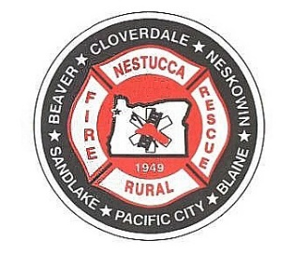

**NESTUCCA RURAL FIRE PROTECTION DISTRICT**

**30710 Highway 101 South**

**Cloverdale, Oregon 97112**

**503-392-3313**

**NOTICE OF**

**NESTUCCA RURAL FIRE PROTECTION DISTRICT**

**BOARD OF DIRECTORS**

**FISCAL YEAR 2025-2026 BUDGET HEARING**

**and**

**REGULAR MEETING**

**and**

**Executive Session per ORS 192.610 to 192.690**

**May 14th, 2025**

**STATION 87 COMMUNITY ROOM**

**HEBO, OREGON**

**at 6:00 pm**

**Regular Monthly Board/District Business**

**The meeting place is accessible to persons with disabilities. A request for an interpreter for the hearing impaired or other accommodation for persons with disabilities should be made 48 hours prior to the meeting time by calling the office 503-392-3313**

**This will be a hosted teleconference, please call the office for information on joining.**

**PLEASE DO NOT REMOVE BEFORE DATE ABOVE**

**THIS IS A REQUIRED PUBLIC MEETING NOTICE**